# Lab: DOM Manipulation

Problems for in-class lab for the [“JavaScript Advanced” course @ SoftUni](https://softuni.bg/courses/javascript-advanced). Submit your solutions in the SoftUni judge system at <https://judge.softuni.bg/Contests/640/>.

## List of Items

Write a JS function that **read** the text inside an input field and **appends** the specified text to a list inside an HTML page.

### Input/Output

There will be no input/output, your program should instead **modify** the DOM of the given HTML document.

|  |
| --- |
| **Sample HTML** |
| <h1>List of Items</h1>  <ul id="items"><li>First</li><li>Second</li></ul>  <input type="text" id="newItemText" />  <input type="button" value="Add" onclick="addItem()">  <script>  function addItem() {  // TODO: add new item to the list  }  </script> |

### Examples

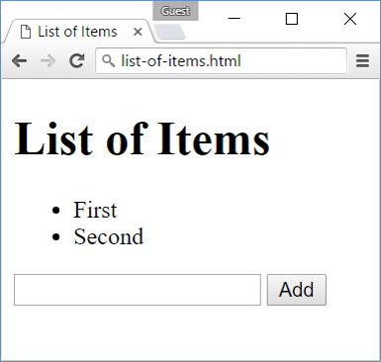 🡪 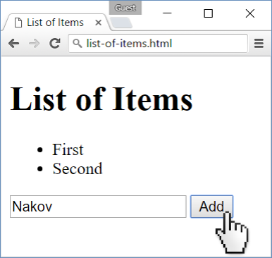 🡪 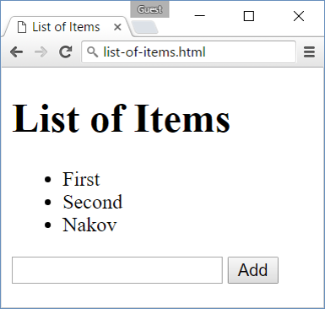

## Add and Delete

Extend the previous problem to display a **[Delete] link** after each list item. **Clicking** it, should **delete** the item with no confirmation.

### Input/Output

There will be no input/output, your program should instead **modify** the DOM of the given HTML document.

|  |
| --- |
| **Sample HTML** |
| <h1>List of Items</h1>  <ul id="items"></ul>  <input type="text" id="newText" />  <input type="button" value="Add"  onclick="addItem()">  <script>  function addItem() { ...  function deleteItem() { ... }  }  </script> |

### Examples

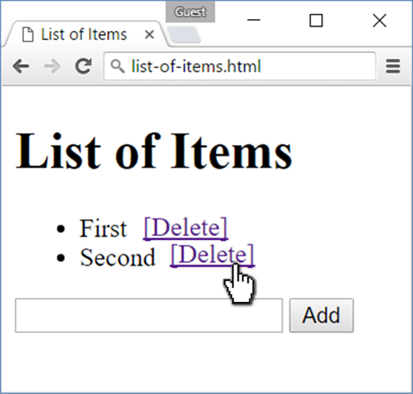🡪 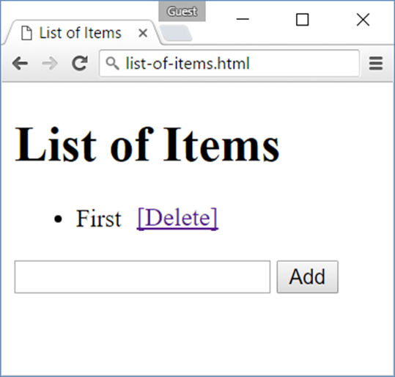

## Delete from Table

Write a JS program that **takes** an e-mail from an **input field** and **deletes** matching rows from a table. If no entry is found, an **error** should be displayed in a <div> with ID "**results**". The error should read "**Not found**."

### Input/Output

There will be no input/output, your program should instead **modify** the DOM of the given HTML document.

|  |
| --- |
| **Sample HTML** |
| <table border="1" id="customers">  <tr><th>Name</th><th>Email</th></tr>  <tr><td>Eve</td><td>eve@gmail.com</td></tr>  <tr><td>Nick</td><td>nick@yahooo.com</td></tr>  <tr><td>Didi</td><td>didi@didi.net</td></tr>  <tr><td>Tedy</td><td>tedy@tedy.com</td></tr>  </table>  Email: <input type="text" name="email" />  <button onclick="deleteByEmail()">Delete</button>  <div id="result" /> |

### Examples

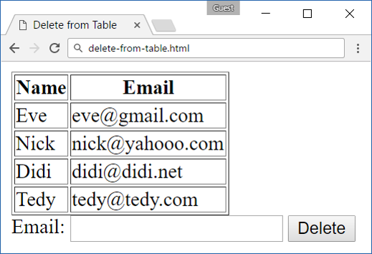 🡪 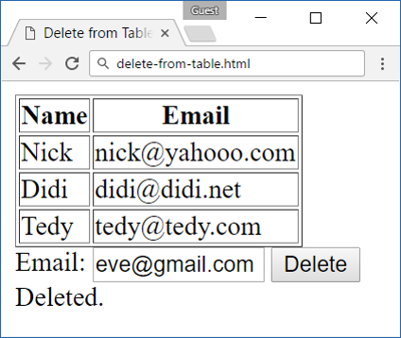

## Stopwatch

Write a JS program that **implements** a web timer that supports **minutes** and **seconds**. The user should be able to control it with **buttons**. Clicking **[Start]** **resets** the timer back to zero. Only one of the buttons should be enabled at a time (you cannot stop the timer if it’s not running).

### Input/Output

There will be no input/output, your program should instead **modify** the DOM of the given HTML document.

|  |
| --- |
| **Sample HTML** |
| <div id="time" style="border:3px solid blue; text-align:center; font-size:2em; margin-bottom:10px">00:00</div>  <button id="startBtn">Start</button>  <button id="stopBtn" disabled="true">Stop</button>  <script>window.onload = function() { stopwatch(); }</script> |

### Examples

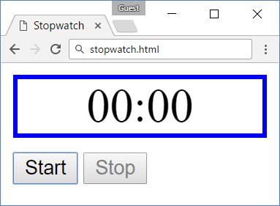

## Mouse Gradient

Write a JS program that **detects** and displays how far along a gradient the user has **moved** their **mouse** on a webpage. Use the provided HTML and stylesheet (CSS) to test locally. The resulting value should be **rounded down** and displayed as a **percentage** inside the **<div>** with ID "**result**".

### Input/Output

There will be no input/output, your program should instead **modify** the DOM of the given HTML document.

|  |
| --- |
| **Sample HTML** |
| <html>  <head>  <title>Mouse in Gradient</title>  <link rel="stylesheet" href="gradient.css" />  <script src="gradient.js"></script>  </head>  <body onload="attachGradientEvents()">  <div id="gradient-box">  <div id="gradient">Click me!</div>  </div>  <div id="result"></div>  </body>  </html> |

|  |
| --- |
| **gradient.css** |
| #gradient-box {  width: 300px;  border: 2px solid lightgrey;  }  #gradient-box:hover {  border: 2px solid black;  }  #gradient {  height: 30px;  color: white;  text-shadow: 1px 1px 10px black;  text-align: center;  line-height: 30px;  background: linear-gradient(to right, black, white);  cursor: crosshair;  } |

### Examples

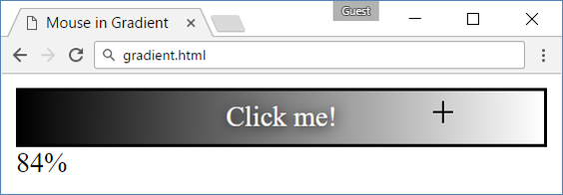

## Highlight Active

Write a JS function to highlight the **currently active** section of a document. There will be **multiple** divs with **inputs** inside them – set the class of the div, that contains the currently focused input field to "**focus**". When focus is lost (**blurred**) **remove the class** from the element.

### Input/Output

There will be no input/output, your program should instead **modify** the DOM of the given HTML document.

|  |
| --- |
| **Sample HTML** |
| <!DOCTYPE html><html lang="en">  <head>  <meta charset="UTF-8"><title>Focus</title>  <style>  div { width: 470px; }  div div {  text-align: center;  display: inline-block;  width: 200px;  height: 200px;  margin: 15px;  border: 1px solid #999;  }  .focused { background: #999999; }  </style>  </head>  <body onload="focus()">  <div>  <div><h1>Section 1</h1><input type="text"/></div>  <div><h1>Section 2</h1><input type="text"/></div>  <div><h1>Section 3</h1><input type="text"/></div>  <div><h1>Section 4</h1><input type="text"/></div>  </div>  <script>  function focus() {  *// TODO*  }  </script>  </body>  </html> |

### Example

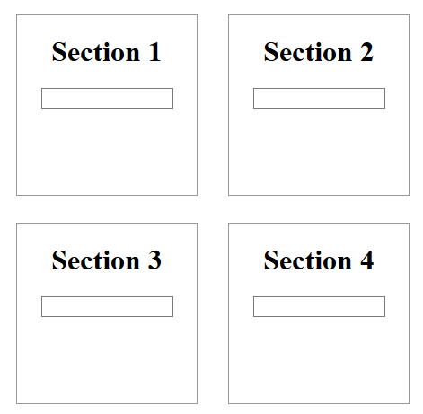 🡪 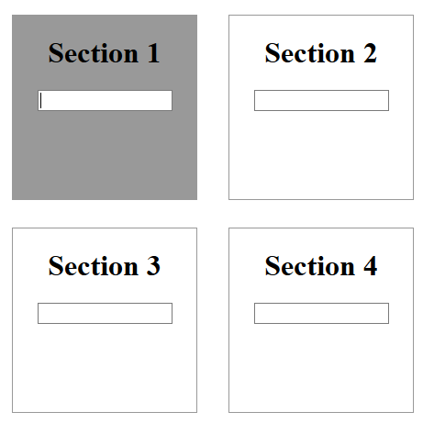

## Dynamic Validation

Write a JS function that dynamically validates an email input field when it is **changed**. If the input is invalid, apply to it the style "error". Do not validate on every keystroke, as it is annoying for the user, only watch of **change** events.

A valid email will be in format: **<name>@<domain>.<extension>**

Only lowercase Latin characters are allowed for any of the parts of the email. If the input is valid, clear the style.

### Input/Output

There will be no input/output, your program should instead **modify** the DOM of the given HTML document.

|  |
| --- |
| **Sample HTML** |
| <!DOCTYPE html><html lang="en">  <head>  <meta charset="UTF-8"><title>Focus</title>  <style>.error { border: 2px solid red; }</style>  </head>  <body onload="validate()">  <label for="email">Enter email:</label>  <input id="email" type="text"/>  <script>  function validate() {  *// TODO*  }  </script>  </body>  </html> |

### Example

 